**NaPDI Repository Experiment Report**

**In Vitro Transport Kinetics Experiment(s)**

**Please fill in all relevant fields to the experiment(s) performed.**

1. **General Information**

|  |  |
| --- | --- |
| **Title of experiment** |  |
| **Research organization** |  |
| **Overall effect cut-off** |  |
| **Test system**  **(see appendix I for options)** |  |

|  |  |  |  |  |
| --- | --- | --- | --- | --- |
| **Experiment number and title** | **Object name (therapeutic class)** | **Object concentration**  **(µM or µg/mL units preferred)** | **Transporters involved (provide all major)** | **Number of experiments conducted** |
| **1.** |  |  |  |  |
| **2.** |  |  |  |  |
| **3.** |  |  |  |  |

(Add more rows if needed)

|  |  |
| --- | --- |
| **Additional information (e.g. please describe if precipitant is an extract or fraction of a natural product, or if a cocktail of probe substrates was used, etc. )** |  |

**An example of data entered in the repository on the admin side:**

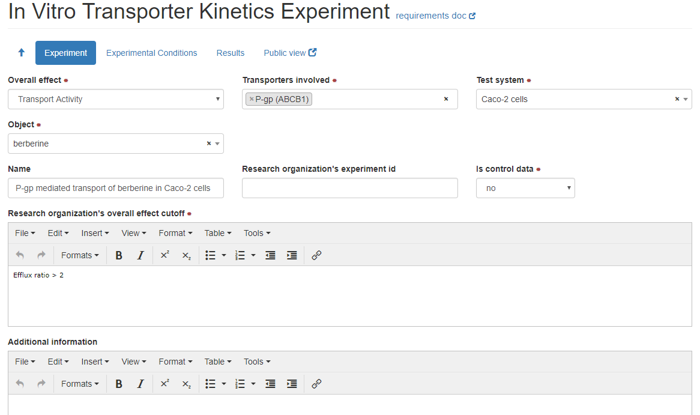

1. **Experimental Conditions**

|  |  |
| --- | --- |
| **Density** |  |
| **Protein concentration or amount/well** |  |
| **Plate type** |  |
| **Number of days (or hours) after plating experiment was conducted** |  |
| **Passage number** |  |
| **TEER threshold** |  |
| **Barrier integrity method** |  |
| **Incubation Time**  **(min units preferred)** |  |
| **Incubation temperature**  **(deg C units preferred)** |  |
| **Incubation pH** |  |
| **Object concentrations tested (µM units preferred)** |  |
| **Object source (manufacturer, lot #)** |  |

**Additional information regarding experimental conditions:**

|  |  |
| --- | --- |
| **Additional Information** |  |
| **Control conditions** |  |

**An example of data entered in the repository on the admin side:**

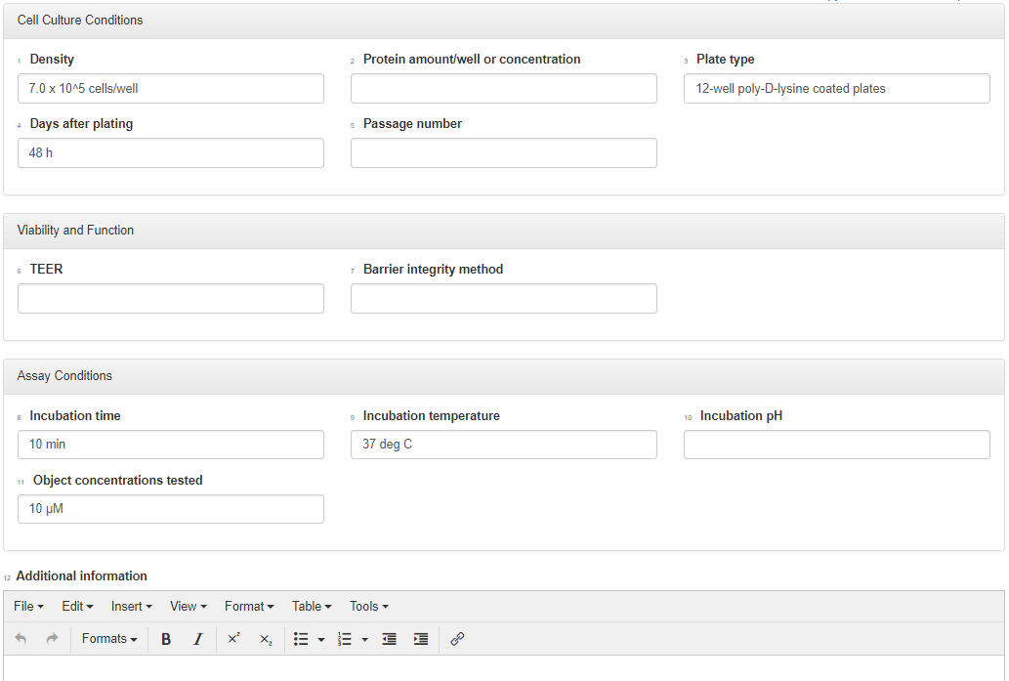

**3. Brief Summary of Results**

**For each experiment, please provide a brief summary of the results and conclusions**

|  |  |  |
| --- | --- | --- |
| **Experiment number and title** | **Transport Inhibition type** | **Results values and types**  **(see appendix II and III for list of parameters and value types)** |
|  | Transport Activity  No transport activity |  |
|  | Transport Activity  No transport activity |  |
|  | Transport Activity  No transport activity |  |

(Add more rows if needed)

|  |  |
| --- | --- |
| Additional Information |  |
| Conclusion |  |

**Attach relevant figures and tables of results when submitting this form.**

**Appendix I: Transport Test Systems**

* **Transfected/injected/siRNA knock-out cells**
* MDCK-transfected cells
* LLC-PK1-transfected cells
* HEK293-transfected
* HeLa-transfected
* CHO-transfected
* HepG2-transfected
* siRNA knock-out hepatocytes
* siRNA knock-out Caco-2 cells
* siRNA knock-out other cells
* X.laevis Oocytes-injected
* Inside-out membrane vesicles
* **Cell types**
* Hepatocytes
* Primary hepatocytes
* Cryopreserved hepatocytes
* Sandwich cultured hepatocytes
* Intestinal epithelial cells
* Caco-2 cells
* Other cells

**Appendix II: Transport kinetics parameters**

|  |  |
| --- | --- |
| **Parameters** | **Preferred unit(s)** |
| **Barrier permeability measurement** | |
| **Papp A-B vector control** | 10-6 cm/s |
| **Papp A-B transfected** | 10-6 cm/s |
| **Papp A-B Caco-2** | 10-6 cm/s |
| **Papp B-A vector control** | 10-6 cm/s |
| **Papp B-A transfected** | 10-6 cm/s |
| **Papp B-A Caco-2** | 10-6 cm/s |
| **Ratio PappB-A/ PappA-B vector control** |  |
| **Ratio PappB-A/ PappA-B transfected** |  |
| **Ratio PappB-A/ PappA-B Caco-2** |  |
| **Ratio transfected/vector control** |  |
| **Permeability rate** |  |
| **Efflux rate** |  |
| **Uptake measurement** | |
| **Fold accumulation vector control** | -fold |
| **Fold accumulation transfected** | -fold |
| **Ratio of fold accumulation transfected/vector control** | -fold |
| **Accumulation rate** |  |
| **Kinetic measurement** | |
| **Km total** | µM |
| **Km unbound** | µM |
| **Percent bound** | % |
| **Vmax or Jmax\*** | nmol/cm2/h  pmol/min/106 cells  pmol/min/pmol  pmol/min/oocyte |
| **Vmax/Km or Jmax/Km\*** | µL/cm2/min  µL/min/pmol  µL/min /106 cells  µL/min /oocyte  mL/cm2/min |

*Provide Fit model (Hill equation and Hill coefficient, Michaelis-Menten, etc.)

**Appendix III: List of value types**

* Mean
* Mean ± SD
* Mean ± SEM
* Mean (range)
* Mean (CV%)
* Mean (CI)
* Median
* Median (CV%)
* Median (range)
* Median (CI)